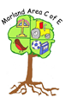
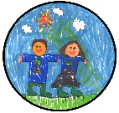
Curriculum Road Map of skills and progression – Morland Area C of E Primary School
Art:
Drawing, painting, colour and tone
Year 4
Skills:
-Children use their sketchbooks and draw thoughtfully displaying understanding of briefs. They show planning of artwork according to this. (e.g. sketchbooks show different ideas and how research has led to the development of work).
-Children use their developing drawing skills to improve the quality of pictures & diagrams in art. (e.g. different drawing techniques and pencils for different purposes – shade, tone, sketching.)
-They think carefully about their own work and compare it with others' work (peers and artists). Discussing similarities and differences between their work and others and planned improvements they could make.
-Describe some key ideas, techniques, styles and working practices of some different artists, craftspeople and designers that I have studied.
can name and talk about tools I have used within my art work and show others how they should be used properly and safely.
4
Year 1
Skills:
-Ideas and objects are expressed and represented by drawing in in art.
-Children experiment with and use drawings using different media to represent an object/person.
-Children experiment with different drawing tools to create a piece of art (drawing, sketches, diagrams) and know different media should be selected for different their qualities and purposes (e.g. crayons/felt tips for colours, pencils for drawings and diagrams, chalks and pastels for colour and blending).
-Examples are collated in a developing sketchbook. Annotations and edits may be recorded.
1
Year 3
Skills:
-Children collect, think about and discuss images/drawings linked to their ideas which help them plan for art briefs.
-Develop drawing skills by experimenting with them and experiencing the qualities of different drawing materials and techniques (e.g. sketching).
-Make sensible and purposeful choices when drawing using a range of drawing tools and techniques to create my own artwork.
-Children reflect, think carefully and explain what they like and dislike about their own work in order to improve it. They can explain what they would do next.
-Children know about and can describe the work of some artists and designers.
-Children can describe and explain the techniques and tools they have chosen to work with.
3
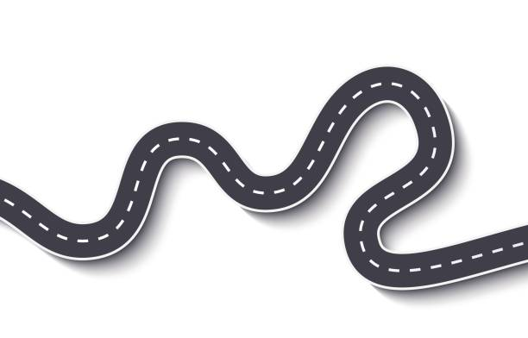







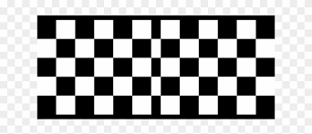

N
R
1
2
5
4
3
6

Nursery
Skills:
-Begin to create closed shapes with continuous lines & use these shapes to represent objects.
-Beginning to use a variety of drawing tools e.g. pencils, crayons, chalk, pens.
-Draw with increasing complexity & detail.
-Drawings begin to represent their intentions such as representing a face with a circle & including details e.g. parts of the face in their drawings.
-Colours (crayons, chalks, felt tips, paints etc) are used and experimented with.
N

Year 2
Skills:
-Try new methods and techniques when drawing and make sensible choices about what to do next within my work. (lines, tone, shading).
-Use drawing to make and record my experiences, ideas and plan my work and annotations in my developing sketch book.
-Practice and improve my control when drawing (e.g. I do not accept the first mark but I try to make improvements).
-Explain what I like and dislike when I look at artwork giving reasons for my choices. (e.g. I like it because…).
-Know that types of art work are made by artists.
-Children talk about the drawing techniques and processes they have used using the correct vocabulary/terminology for processes and tools.
2

Year 6
Skills:
-Children work independently develop a range of ideas which show curiosity, imagination and originality.
-Use a systematic approach to drawing work and techniques. They investigate, research and test ideas and plans using their sketchbook. They indicate well-chosen relevant visual information from their research in my art work.
-Children can explain what they have done to further drawing and recording skills to improve my mastery of art techniques giving reasoned evaluation of both my own and professional’s work which takes account of the starting points.
- Children can create successful finished work independently according to the provided brief and make sensible choices when selecting suitable drawing styles and processes for this.
- use a variety of recording methods, techniques and processes to combine and organise line, shape, form and space, colour, tone, pattern and texture within drawing.
-can describe, interpret and explain the work, ideas and ways of working of some artists and designers studied. Begin to link this to historical cultural/social contexts in which they worked and how this may have influenced them.
- know and use the technical vocabulary within drawing.
6
Reception
Skills:
-Use a range of drawing tools competently & safely (e.g. pencils, pens, crayons, chalks).
- Create representations of both imaginary & real-life ideas, events, people & objects.
-Drawings of people and things become more accurate representations of people with more accurate facial features.
- I can respond imaginatively to artworks & objects.
-I can explore, use & refine a variety of artistic effects and express my ideas & feelings through drawing.
R

Year 5
Skills:
-Develop personal drawing ideas inspired from artist research.
-Confidently use my sketchbook for different purposes involving drawing including: recording observations, developing ideas, testing drawing techniques, planning artwork and recording information.
-show confidence when investigating new and drawing tools and ways of using them.
- use art skills and experience to produce work which matches ideas and plans well according to the brief, thinking about the progress of my work taking account of what I had planned to achieve. I can describe how my work has developed and make modifications and improvements to create a high quality outcome.
5

