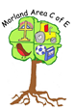
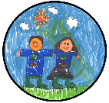
Year 4
Skills:
-Use mosaic- combine visual and tactile qualities with developed technique and intended/planned choices.
-Experiment with and combine materials and processes to design and make 3D form.
-Sculpt clay and other moldable materials.
-Use textile sewing skills as part of a project e.g. Artweek collaborative work.
-Experiment with different styles which artists have used.
-Explain Art from other periods of History - Link to York residential- Cathedral visit and Art within.
-Use sketchbooks -express feelings and outline likes and dislikes, improvements and adaptations they may make in the future, keep notes about the purpose of their work.
-Compare and discuss ideas with others using sketchbooks.
-Learn about the work of others by researching books, internet, visiting galleries and other sources of information.

4
Curriculum Road Map of skills and progression – Morland Area C of E Primary School
Art:
3D, materials, sculpture and collage.
Year 1
Skills:
-Gather materials they will need.
-Sort and organise materials e.g. threads/fabrics by colour & texture.
-Weave with fabric and thread.
-Add texture to constructions by using tools.
-Make different kinds of shapes.
-Manipulate materials such as clay/dough by cutting, rolling & coiling.
-Cut & tear paper and card for collage work.
-Describe what they see and likes/dislikes of Artists.
-Ask sensible questions about a piece of art.
1
Year 3
Skills:
-Cut materials accurately & with purpose.
-Can overlap materials, use mosaic and montage.
-Experiment with colour for effect.
-Can add onto their work to create texture and shape. Work with life size materials.
-Use more than one type of stitch and join fabric together.
-Use sewing to add detail to a piece of work (Artweek).
-Use sketchbooks to express feelings and opinions about their work and that of artists. Note techniques used and suggest improvements they may make.
-Compare the work of different artists and work from other cultures.
-Explore and discuss work from other periods of time (Stone Age).
-Begin to understand view points of others - looking at images of works and share thoughts about their perceptions of what artists are trying to express in their work - record in sketchbooks keeping notes.
-Use sketchbooks to record thoughts/feelings and improvements they may make to work. Add adaptations and improvements to original ideas.

3
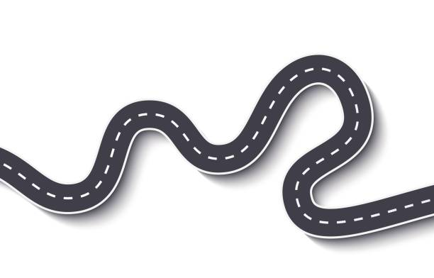







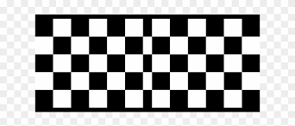

N
R
1
2
5
4
3
6

Nursery
Skills:
-Explore different materials freely, develop ideas of how to use them &. what to make.
-Join different materials & explore different textures.
-Experience and enjoy handling and manipulating different materials explore different textures.
-Use a variety of construction materials.
-Develop own ideas & decide which materials to use with reasons.
-Notice what other children, adults and artists do - begin to practise techniques observed and discuss likes and dislikes.

N

Year 2
Skills:
-Gather materials they will need-explaining why.
-Tear & cut paper / card needed for collages with increasing care.
-Add texture by using tools for a planned effect e.g. intentional shapes.
-Manipulate materials such as clay/dough by cutting, rolling & coiling with increasing care and intention.
-Describe what they see and likes/dislikes of Artists.
-Ask sensible questions about a piece of art.
-Begin to add to work to create texture and shape.
-Annotate/make notes in sketchbooks as to their opinions of their work.

2

Year 5
Skills:

-Use mosaic to create a piece of art.
-Combine visual and tactile qualities to express mood and emotion.
-Experiment with and combine materials and processes to design a nd make 3D form.
-Sculpt clay/other mouldable materials.
-Use textile and sewing skills as part of a project e.g. hanging tile, textile book (Art Week whole school banner, bookmark). Include running stitch, cross stitch, backstitch, appliqué/embroidery.
-Experiment with different artists styles, investigate the work of other artists using books, internet, gallery visits (London National gallery residential, local ‘The Studio’).
-Sketchbooks - develop sketchbook notes as to how they might develop their work further identifying adaptations, improvements and reasoning what changes would develop the piece.
-Use sketchbooks to compare and discuss ideas with others.
-Do sketches communicate emotion, sense of self with accuracy and imagination. Record styles and qualities within their work and explain what their work is influenced by.
-Include technical aspects in their work e.g. architectural design (Residential to Paris - work based on architectural design - Eiffel Tower and own structure design influenced by visit).

5
Reception
Skills:
-Experiment to create different textures.
-Use tools to create different textures.
-Use a range of materials to create different textures.
-Manipulate materials to have a planned effect.
-Develop own ideas through experimentation with a range of materials to express & communicate their discoveries & understanding.
-Respond imaginatively to artworks & objects.
-Explore, use & refine a variety of artistic effects to express their ideas & feelings in the form of art work & objects.

R
Year 6
Skills:
-When combining materials can justify what and why they chose them. Can combine pattern, tone and shape.
-Can create models on a range of scales (Structures unit linking to Paris and London residential visiting significant buildings and structures).
-Can create work which is open to interpretation by the audience (design own building/structure following French/London residentials - designing unit).
-Can include visual and tactile elements in their work - Artweek - collaborative project working with textile artist Jenny Brook to make a new whole school banner celebrating the schools 50th birthday.
-Sketchbooks contain detailed notes explaining choices for their work.
-Begin to compare their methods to those of others keeping notes in their sketchbooks.
-Adapt and refine work to reflect the planned intended purpose and to reflect the meaning keeping, and adding, notes and annotations in sketch books.
-Children describe what and who their work has been influenced by.
-Children include technical aspects to their work e.g. architectural design.

6

